**Session 8 – Kubernetes Operations Lab**

**Clean up old clusters**

Delete the existing cluster if it exists

% kind delete cluster --name tamlab

**Create a Kubernetes v1.20.2 cluster with KIND**

% kind create cluster --name tamlab --config kind-config.yaml --image kindest/node:v1.20.2

You should get something similar to the following output:

Creating cluster "tamlab" ...

✓ Ensuring node image (kindest/node:v1.20.2) 🖼



⢄⡱ Preparing nodes 📦 📦 📦

✓ Preparing nodes 📦 📦 📦

✓ Writing configuration 📜

✓ Starting control-plane 🕹️

✓ Installing CNI 🔌

✓ Installing StorageClass 💾

✓ Joining worker nodes 🚜

Next, view the available clusters

% kind get clusters

* You should see tamlab as one of the clusters

**Install and open Octant to view on-going deployments**

Octant website: https://octant.dev/

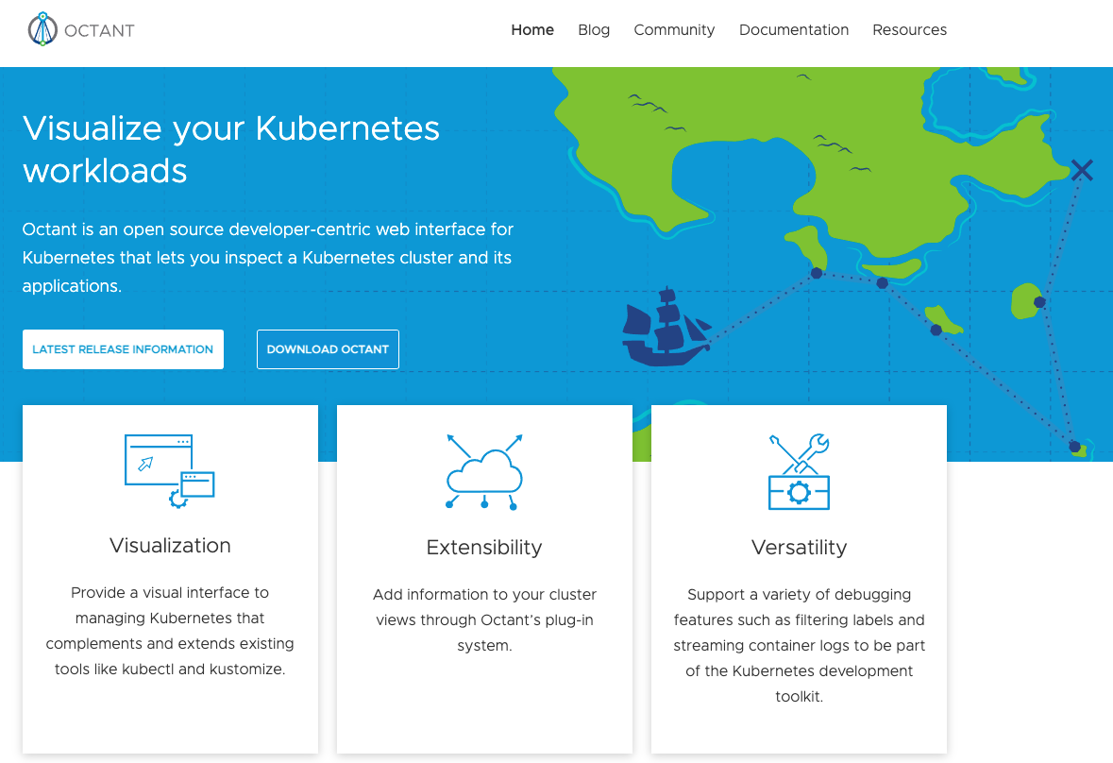

Install octant on macOS

Open a command shell

% Brew install octant

% octant

* This should open a browser window

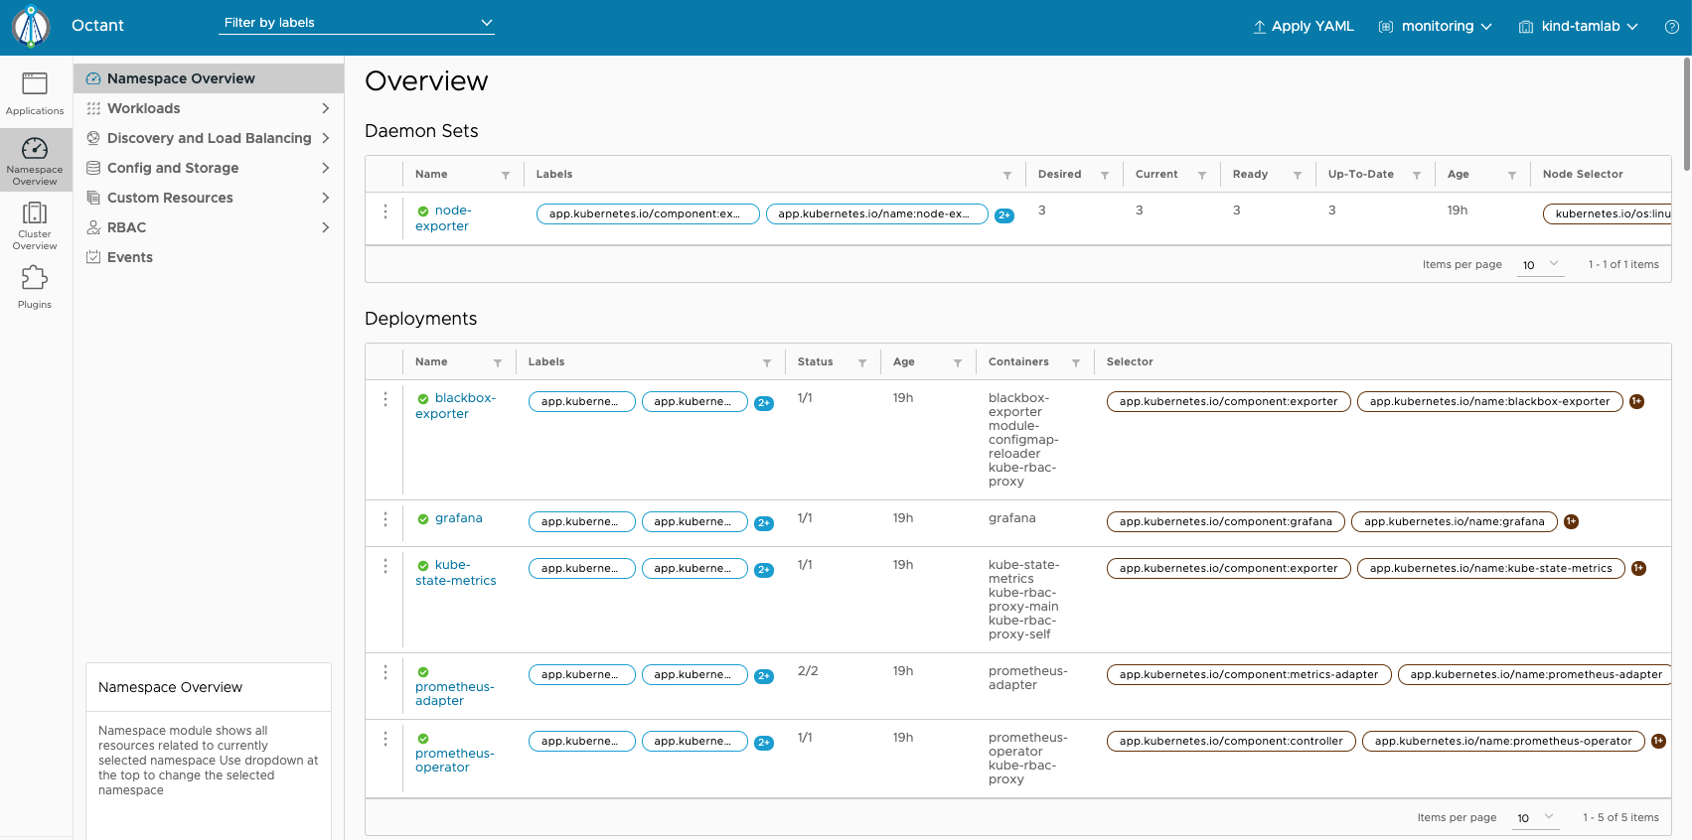

**Logging with EFK (ElasticSearch, Fluentd, Kibana)**



Change directory into the one containing session8-kubernetes-operations

Let’s deploy the logging namespace in the tamlab cluster. When you apply the namespace.yaml file, kubernetes creates the “logging” namespace

% cd logging

% kubectl apply -f namespace.yaml

% kubectl get namespaces

* You should see “logging” as one of the available namespaces

In Octant, pull down the namespace menu and select “logging”

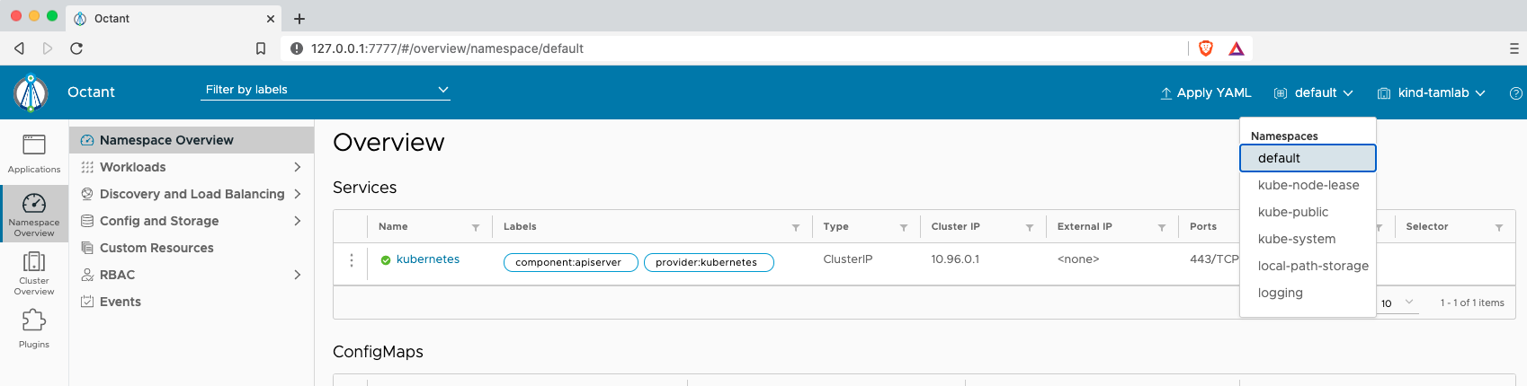



**Deploy Elasticsearch**

Elasticsearch website: https://www.elastic.co/elasticsearch/

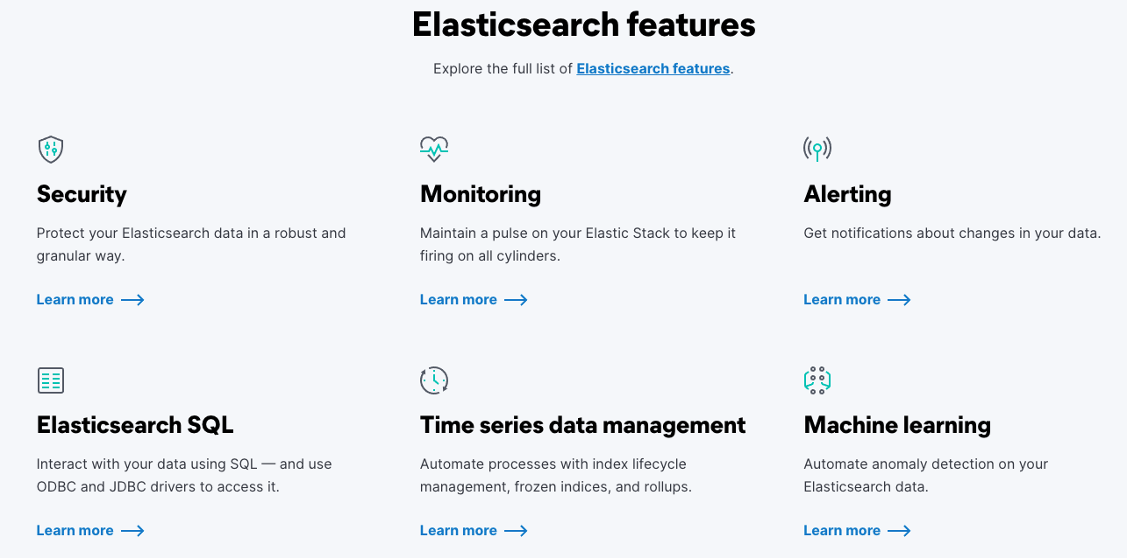

Review Kubernetes concepts in elasticsearch.yaml

% kubectl apply -f elasticsearch.yaml

#wait for elasticsearch statefulset to come up - this will take several minutes. Here’s a refresher on stateful sets from session 4:



This can take quite some time – monitor the progress using:

% kubectl rollout status sts/es-cluster --namespace=logging

Once you see “partitioned roll out complete: 3 new pods have been updated...” then continue:

% kubectl -n logging get all,pv,pvc

% kubectl -n logging describe pod/es-cluster-0

Note the work the “Init Containers” have done to prepare for this Stateful Set (<https://kubernetes.io/docs/concepts/workloads/pods/init-containers/>)

In Octant, you can also watch the pods, stateful sets and service being created:

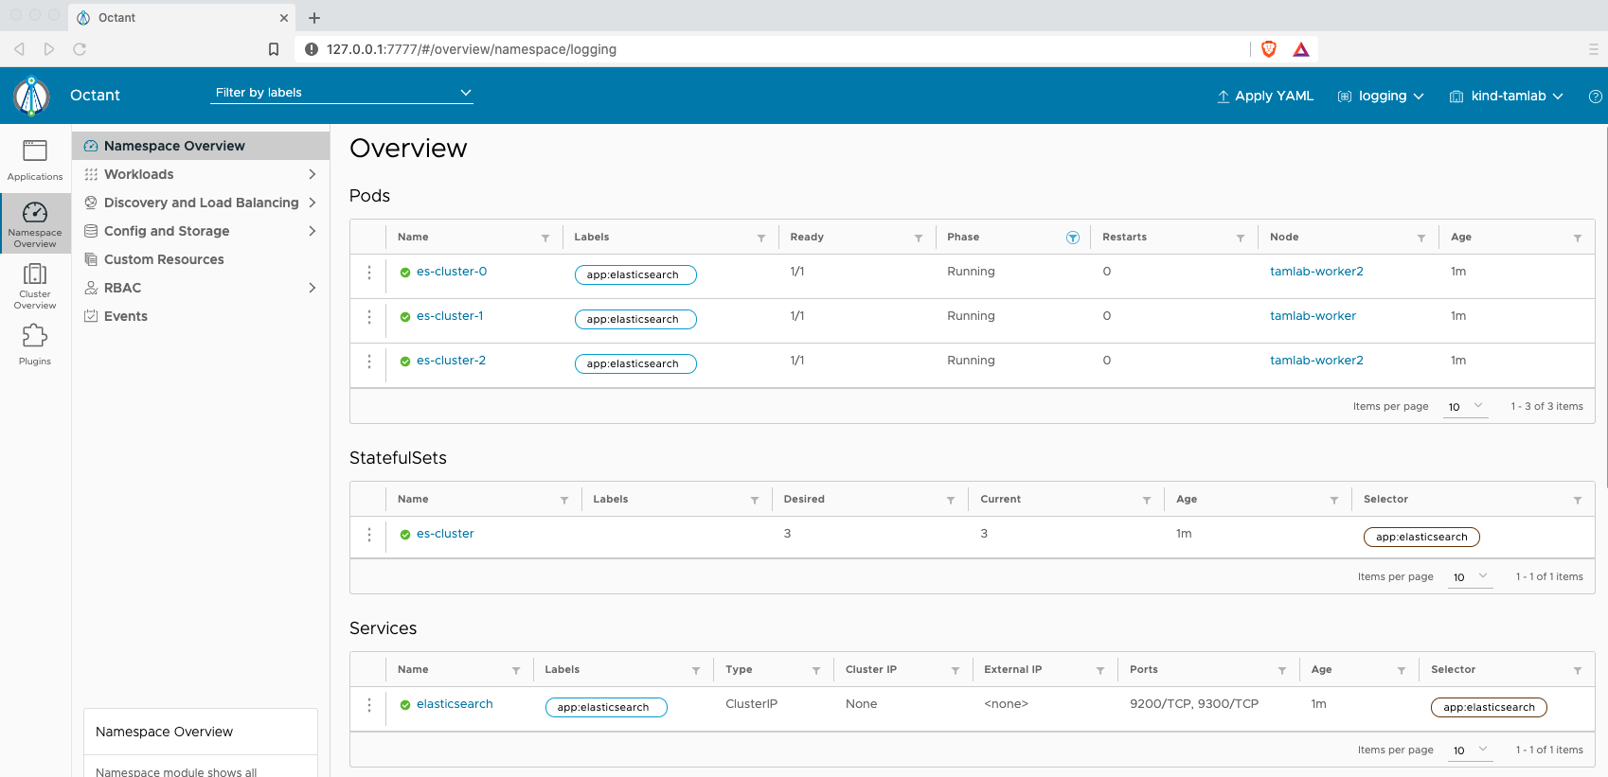



Also, in octant, scroll down and you can see PVC’s and the events:

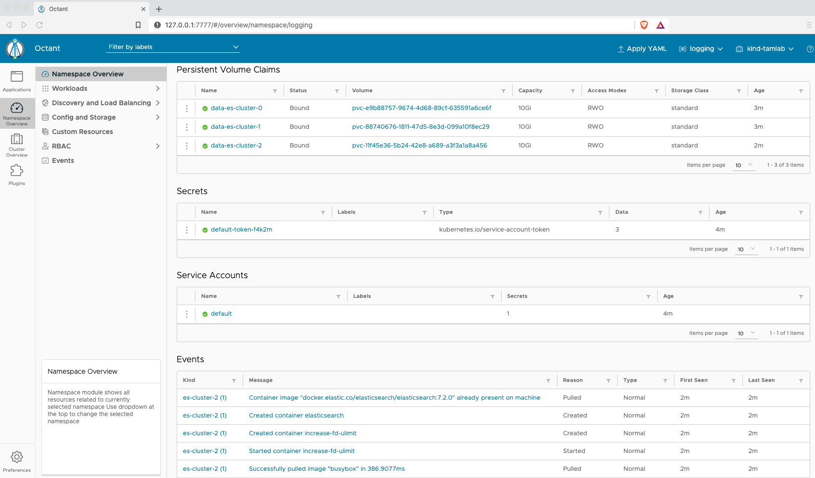

Before we deploy Kibana, the graphical front-end we’ll be using for Elasticsearch, let’s check that the Elasticsearch cluster is working OK by querying the API:

Forward the local port 9200 to port 9200 on one of the Elasticsearch nodes (e.g. es-cluster-0):

% kubectl port-forward es-cluster-0 9200:9200 -n logging

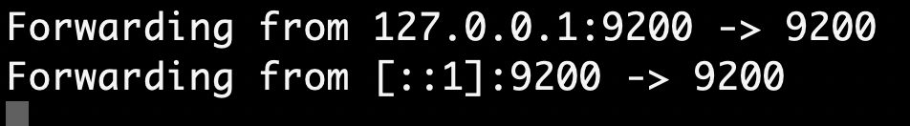

In another terminal window, use curl to query the Elasticsearch API:

% curl http://localhost:9200/_cluster/state?pretty

(NB – depending on which shell you use, you may have to wrap the URL in quotes (e.g. I had to do this with zsh)

If everything is working OK, you will get a lot of output, but it should start with some general config information about the Elasticsearch cluster:

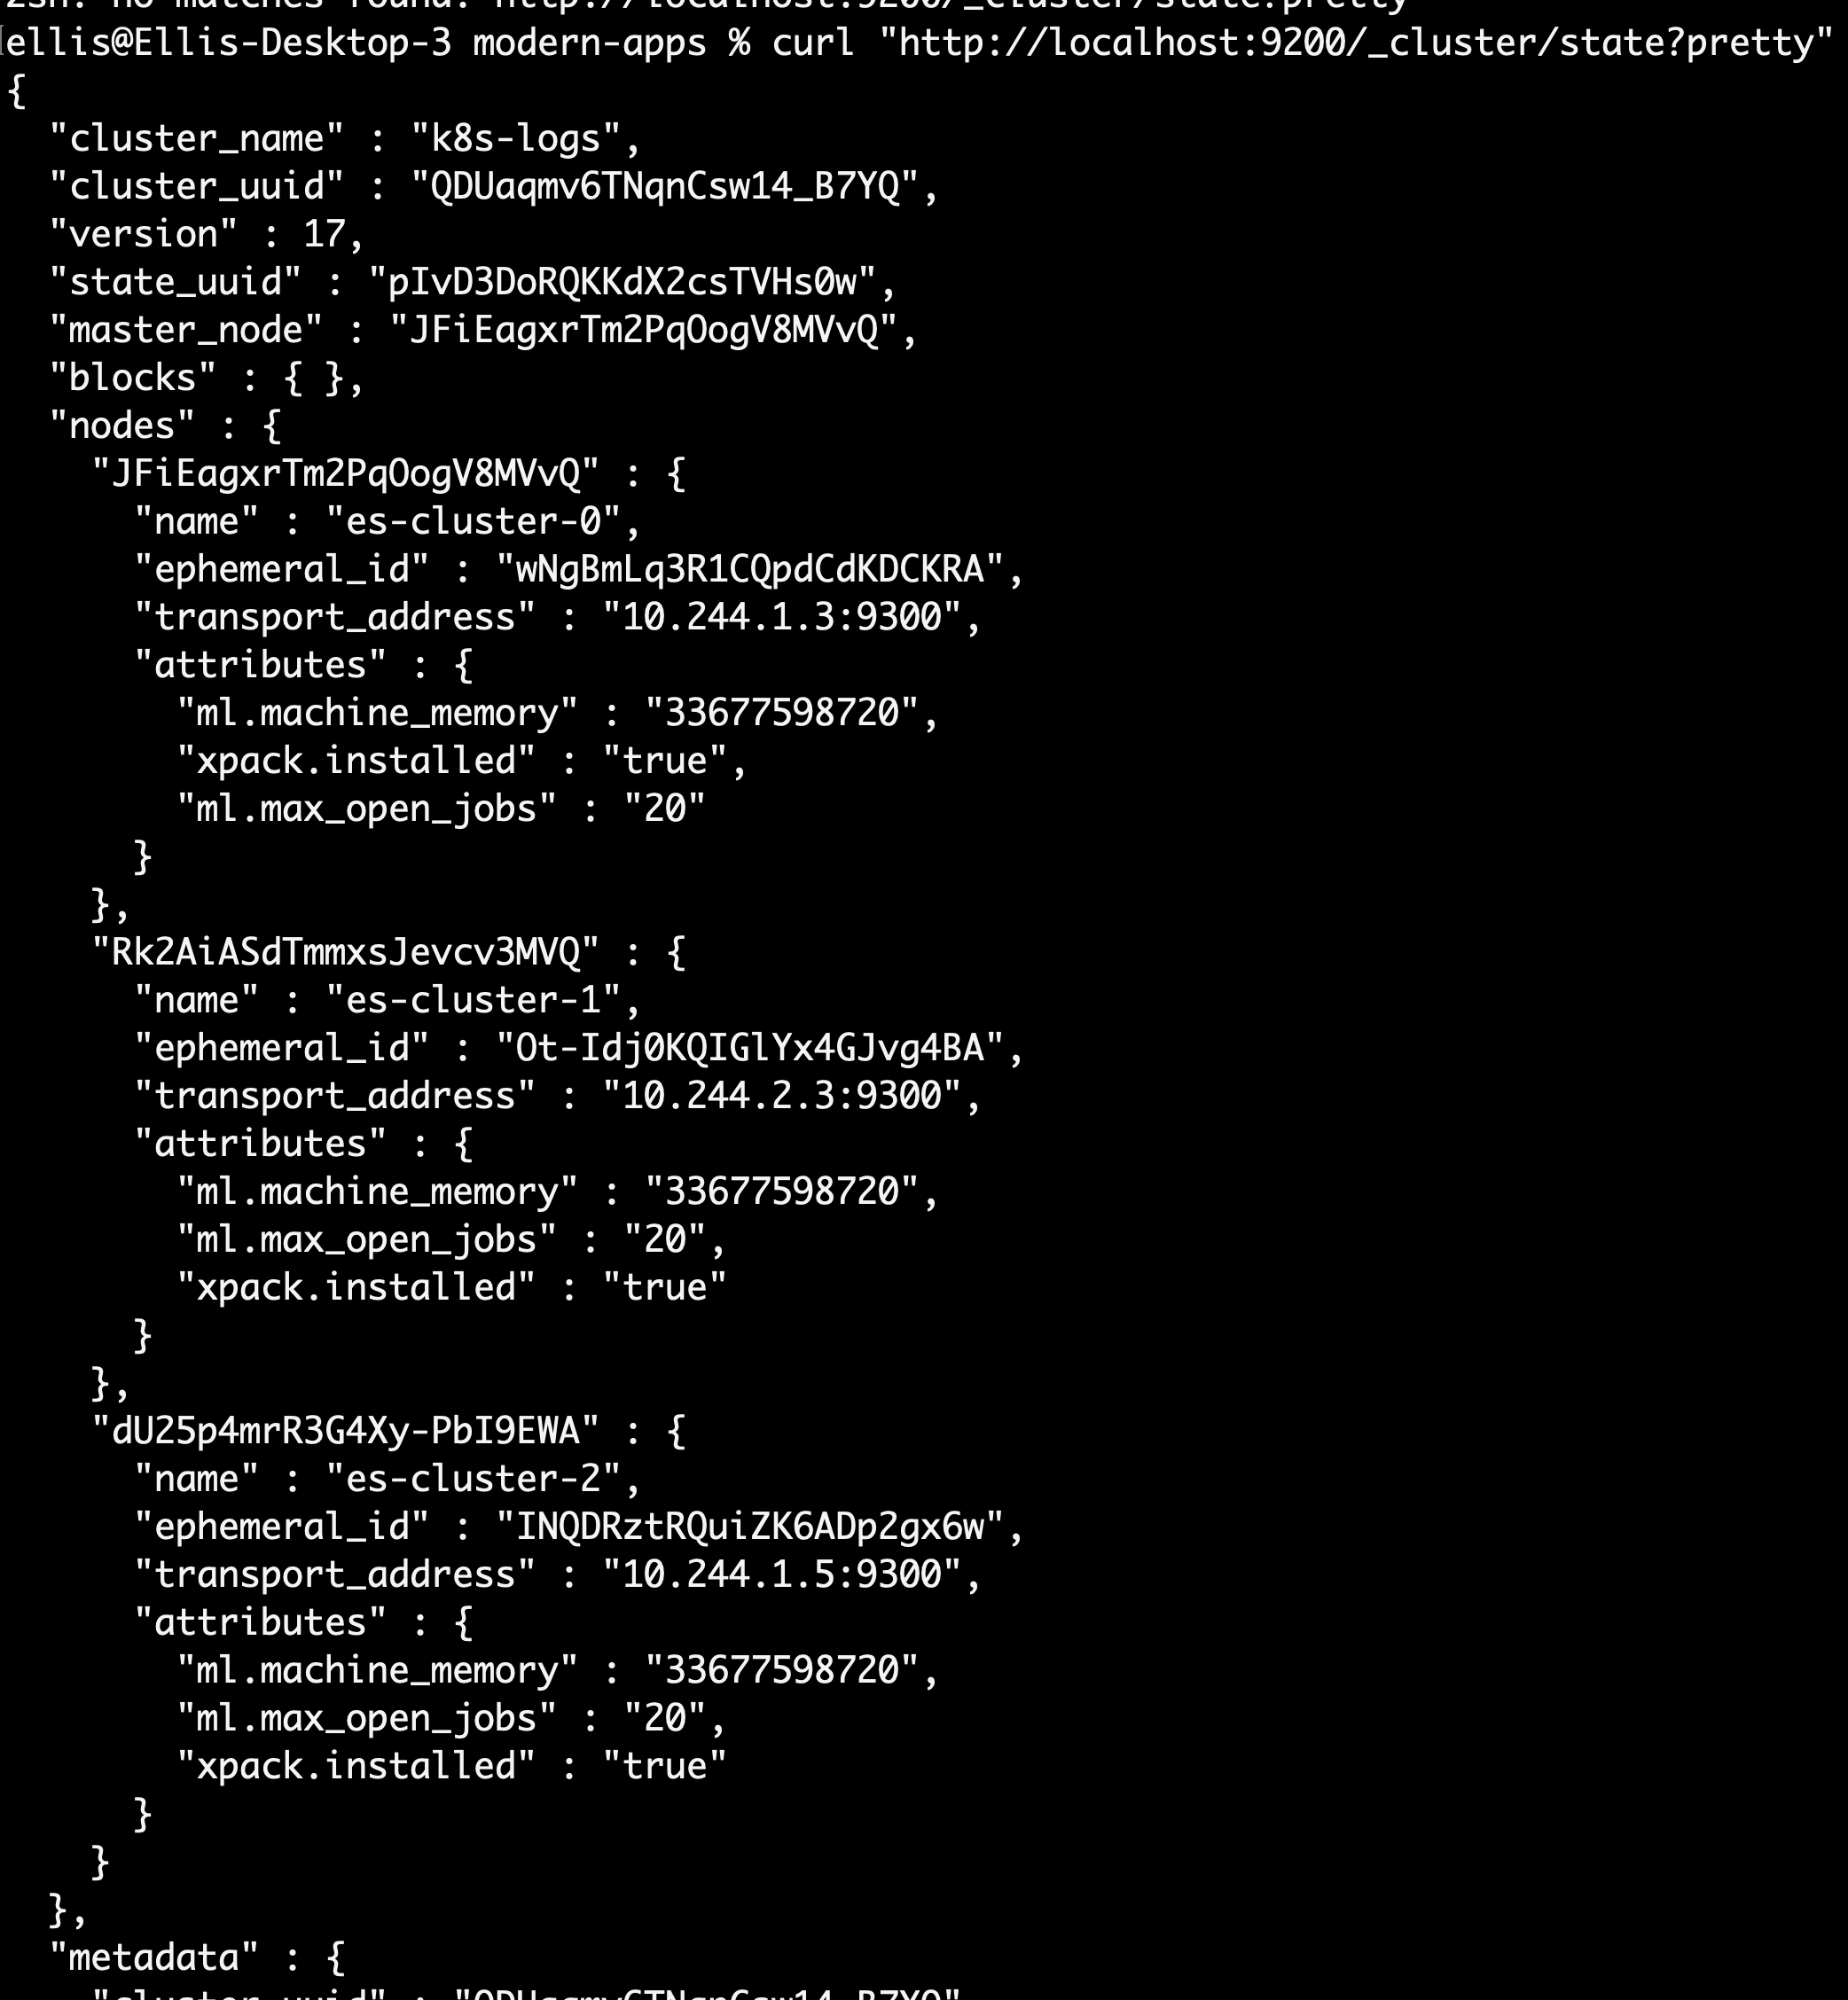

**Deploy Kibana**

Kibana website: https://www.elastic.co/kibana

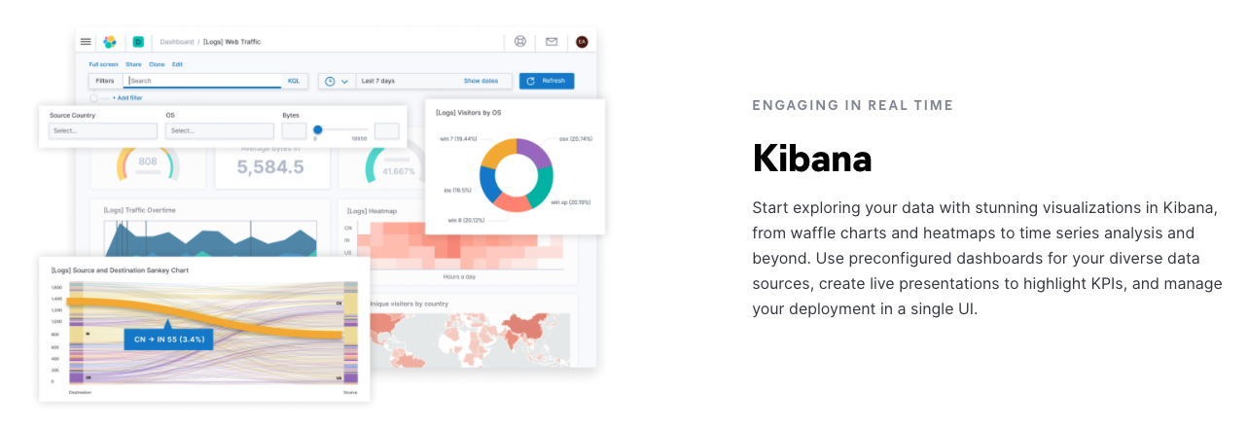

Let’s review a Kubernetes concept in kibana.yaml.

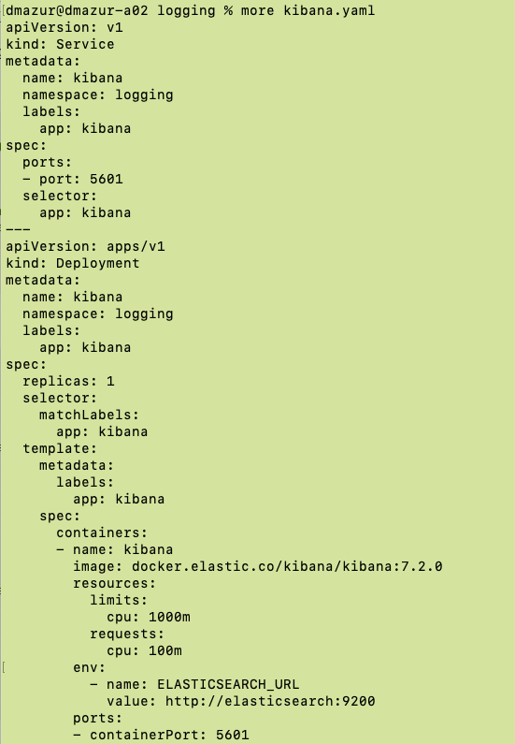

Note the resource limits for the container. Here’s a refresher on resource limits from Session 5:



Now deploy the kibana application:

% kubectl apply -f kibana.yaml

As usual you can follow progress from the CLI (“kubectl get all -n logging”) or from Octant, or by checking the rollout status:

% kubectl rollout status deployment/kibana -n logging

We have a search engine and a front-end for the search engine but as yet no logs are being collected. We’ll use Fluentd to do that.

**Deploy Fluentd**

Fluentd website: <https://docs.fluentd.org/container-deployment/kubernetes>

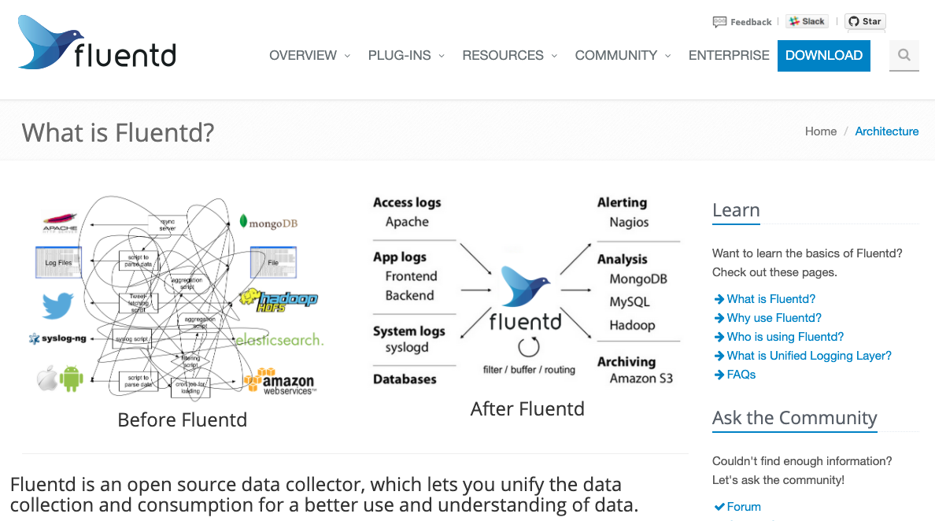

Review Kubernetes concepts in fluentd.yaml. Fluentd takes advantage of Daemonsets. An instance of fluentd will run on every node in the cluster to collect the log files. Also, note the cluster roles and cluster role bindings in the fluentd.yaml file.



Deploy the fluentd application:

% kubectl apply -f fluentd.yaml

Check Fluentd Daemonset:

% kubectl get ds -n logging

…we should see the number of pods equal the number of nodes we have:



**Access Kibana**

Open a separate terminal window

List the pods in the logging namespace:

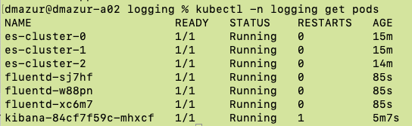



% kubectl -n logging port-forward pod/kibana-<suffix> 5601:5601



open browser to http://localhost:5601

If all is well you will see the Kibana welcome page:



Click **Explore on my own**

Click **Discover** icon in top left:

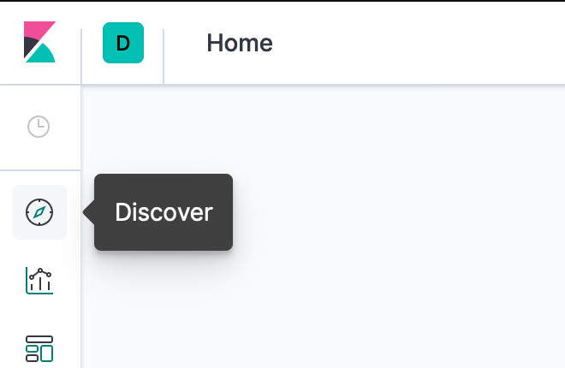

In the resultant Index pattern text box, type “logstash-*” and click **Next step**

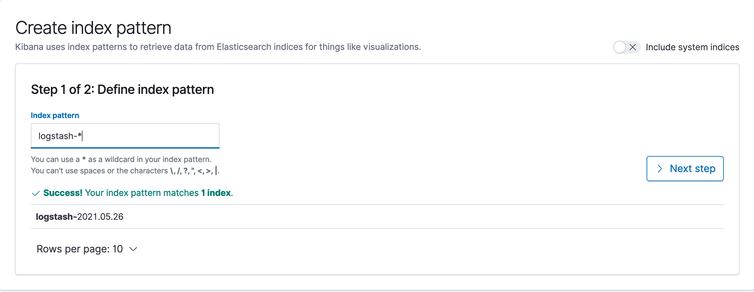

For step 2 of 2, choose “@timestamp” from the drop-down and click **Create index pattern**:

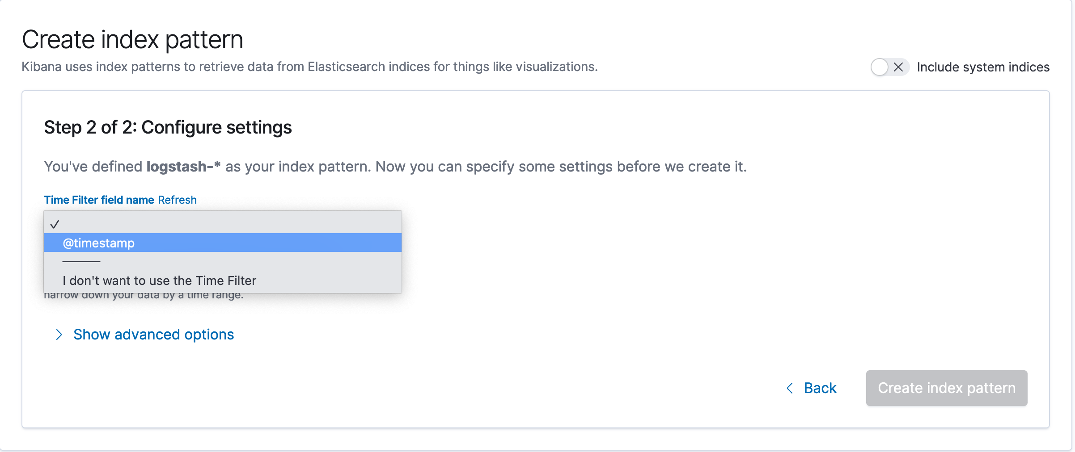

Click **Discover** again, we should now see live log entries from our cluster and pods:

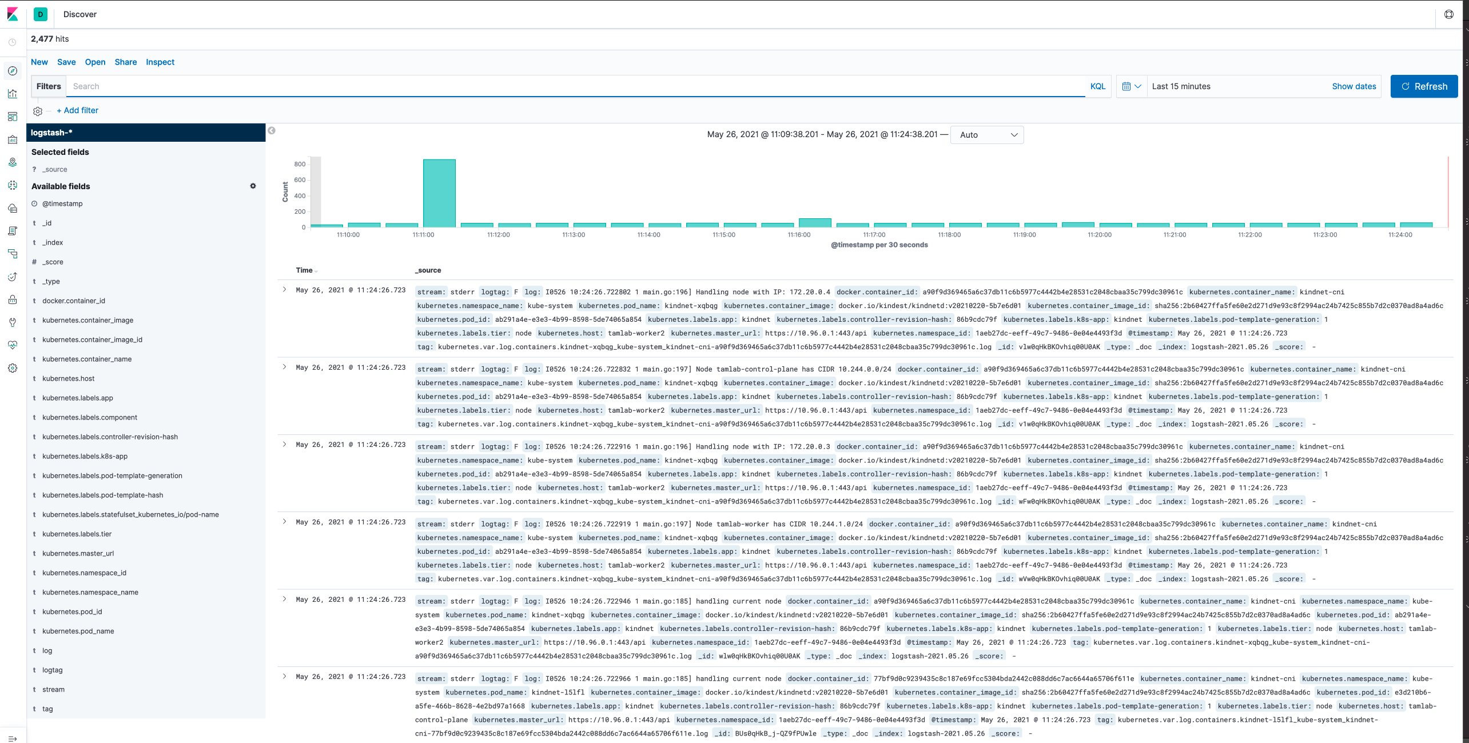

Deploy a container with test log output:

% kubectl apply -f counter.yaml

From the Discover page in Kibana enter **kubernetes.pod_name:counter** and press enter:

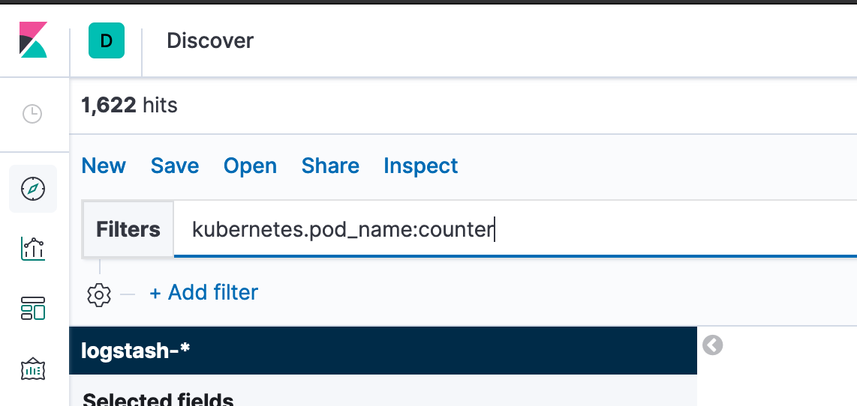

We now see entries from our test pod. Expand one of the entries to see more information:

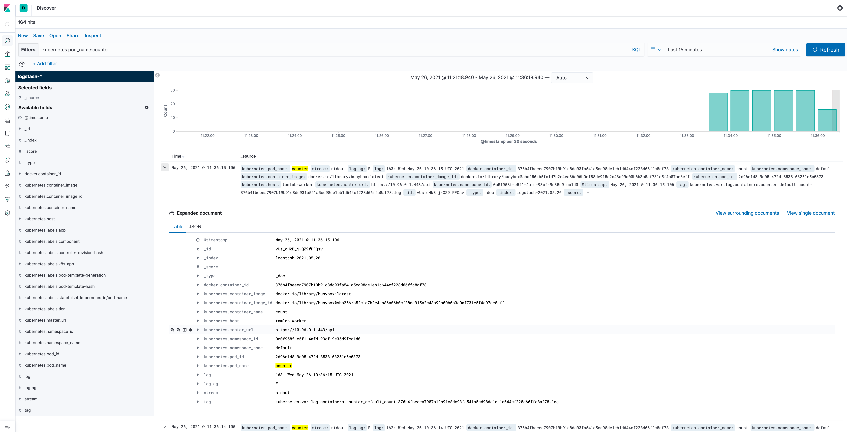

**Deploy cAdvisor**

**cAdvisor website:** https://github.com/google/cadvisor

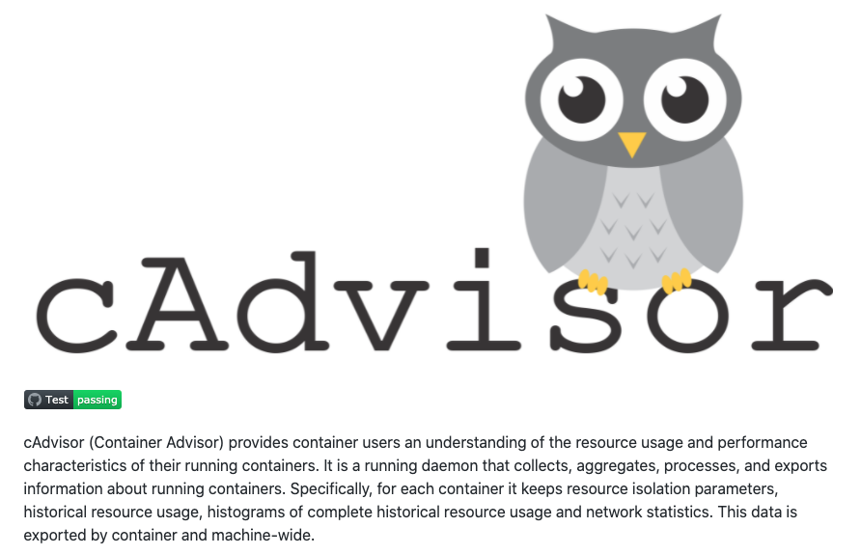

% cd ..

% kubectl apply -f cadvisor/cadvisor.yaml

open browser to: http://localhost:31194/containers/

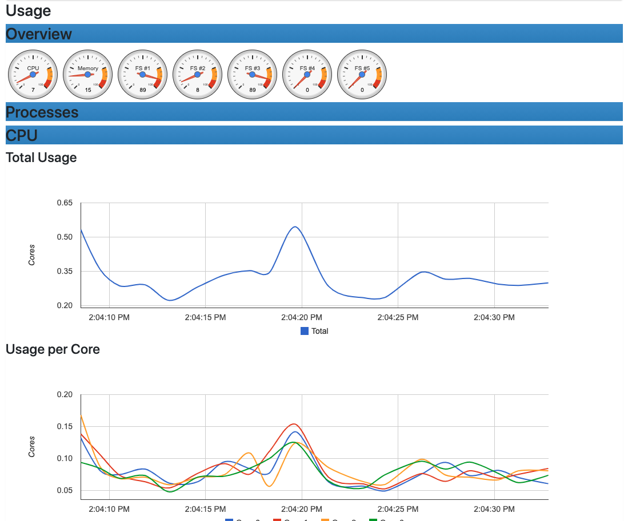

**Install the Prometheus operator and Grafana**

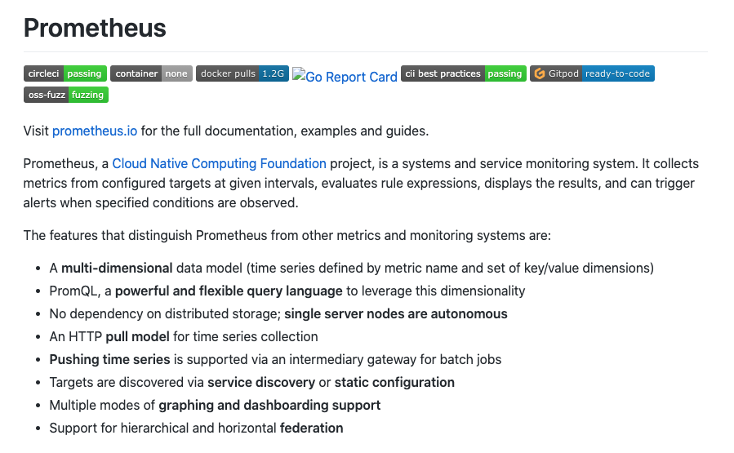

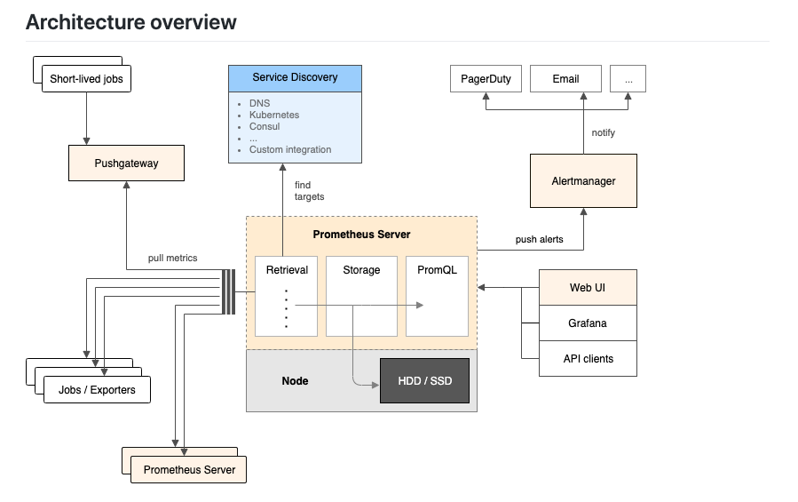

#git clone the kube-prometheus code locally

% git clone https://github.com/prometheus-operator/kube-prometheus.git

% cd kube-prometheus

#setup namespace and CRDs

% kubectl create -f manifests/setup

You should see something similar to:

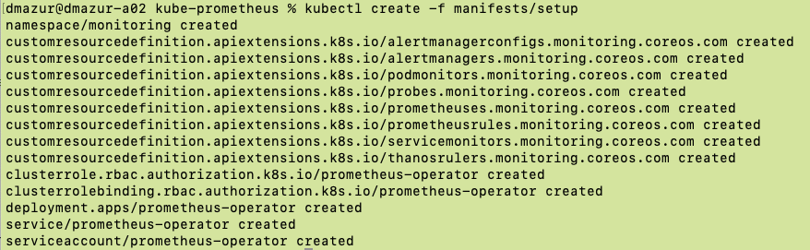

**Review Operators from last session**

* Prometheus and grafana use operators to install and configure the complex application. Here’s a review of operators.



#deploy prometheus operator

% kubectl create -f manifests

% kubectl -n monitoring get all,pv,pvc

In Octant, first select the “monitoring” namespace which was created via the operator. You can also watch the deployments, daemonsets, pods, replicasets, etc being created:

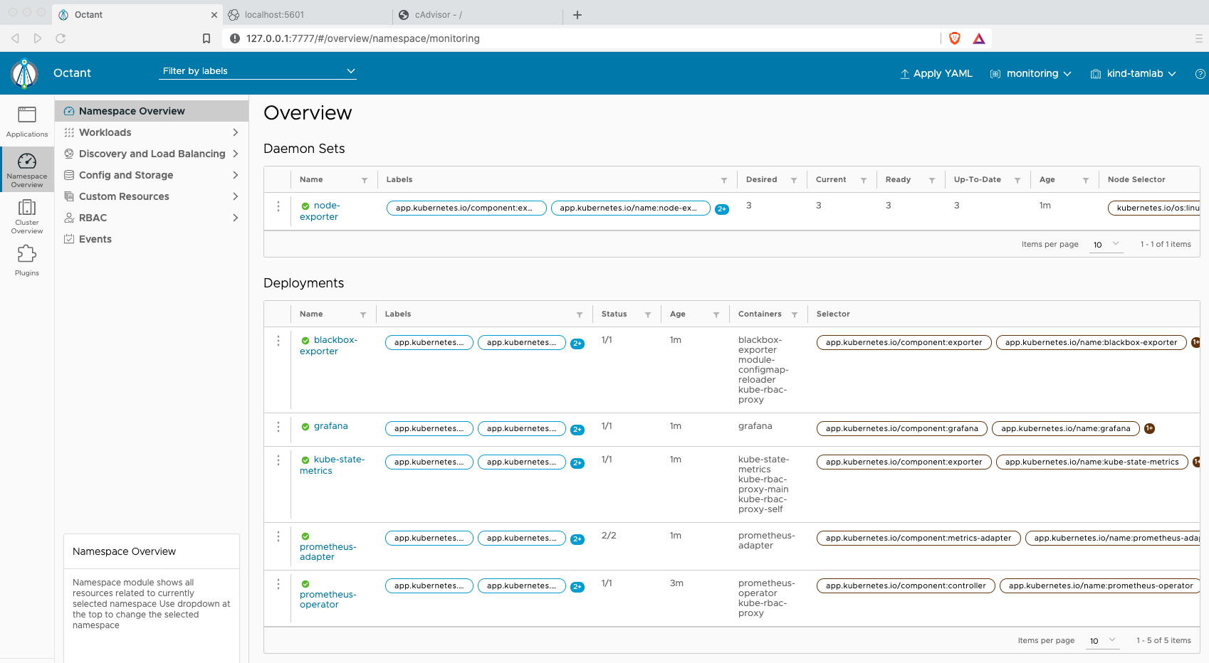

Review components installed

* AlertManager (<https://prometheus.io/docs/alerting/latest/alertmanager/>)
* BlackBox (<https://devconnected.com/how-to-install-and-configure-blackbox-exporter-for-prometheus/>)

#explore Prometheus

# open a new terminal window

% kubectl -n monitoring get pods

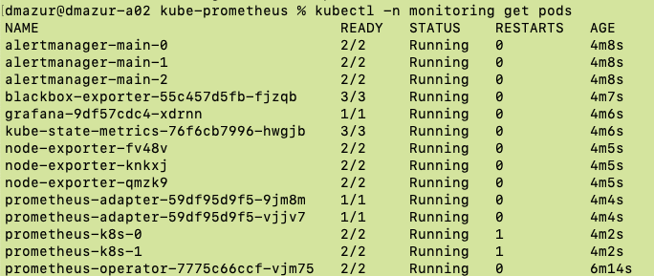



% kubectl -n monitoring port-forward pod/prometheus-k8s-0 9090

open browser to <http://localhost:9090>

Look at alerts:

* Select “Alert” then “Watchdog” pulldown:

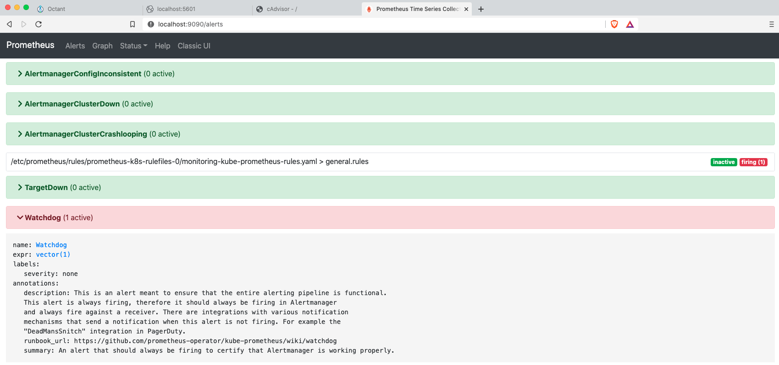



Next, look at “Graphs”

* Select the “Graph” tab then the “Metrics Explorer”

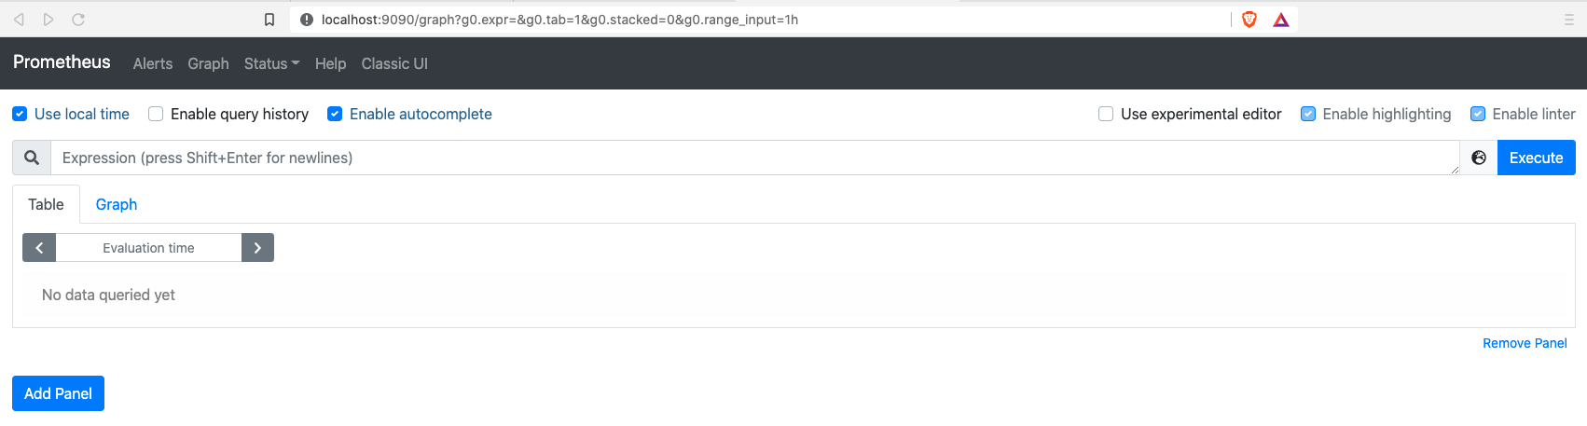



You should see a list of metrics.

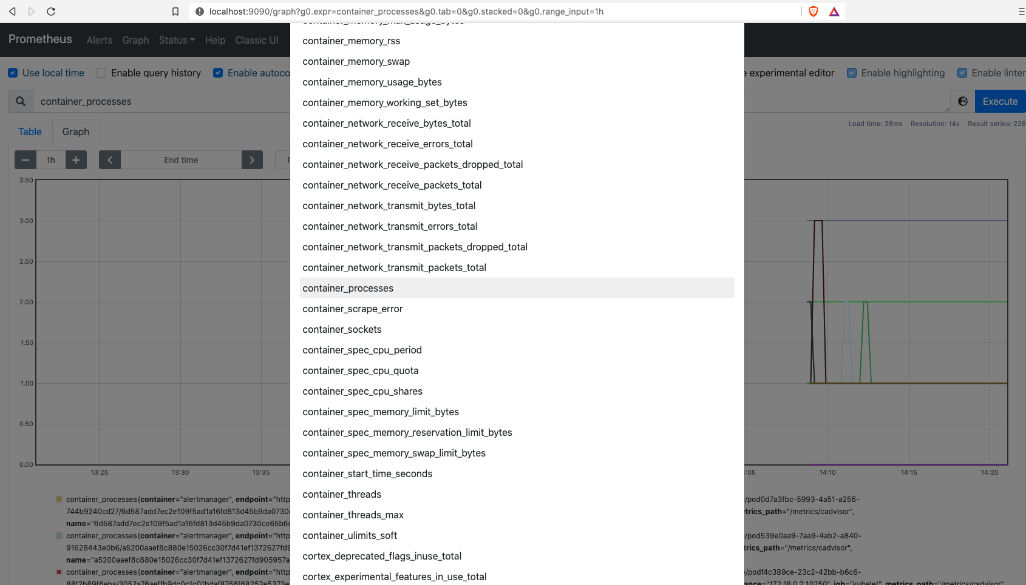



Select the “container_processes” menu item

Then select “Execute” and the “Graph” tab:

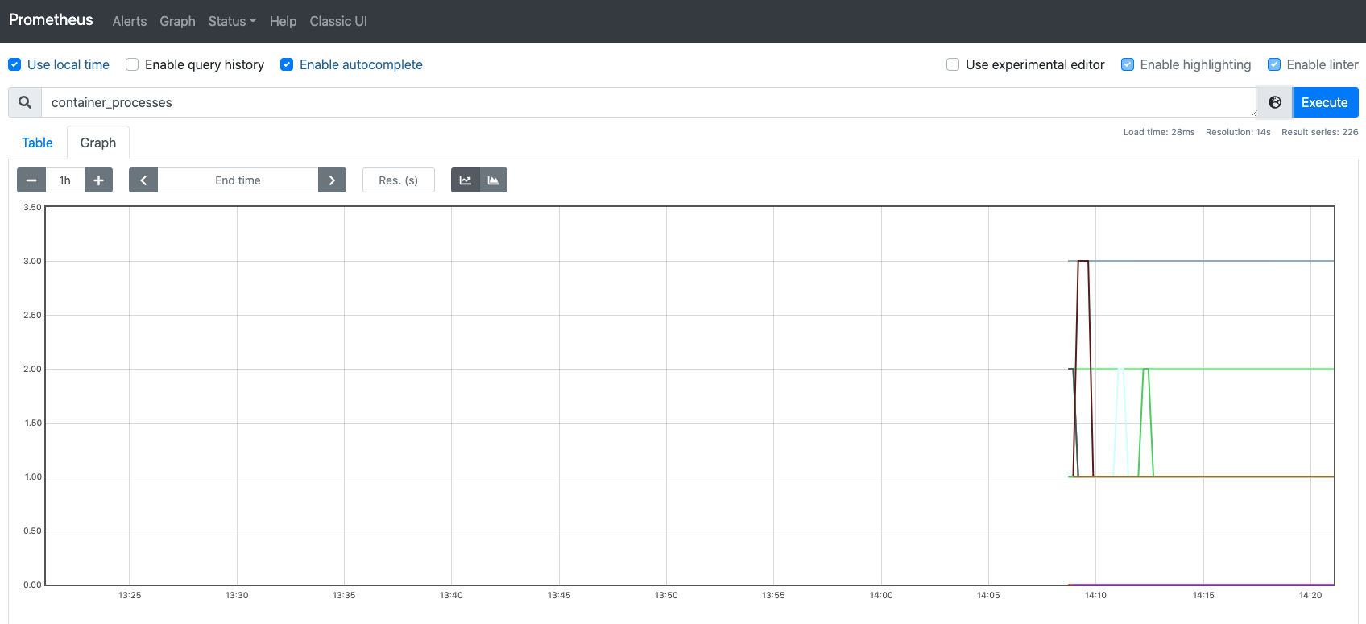



You should see data generated

**Explore Grafana**

#open a new terminal window

% kubectl -n monitoring get pods

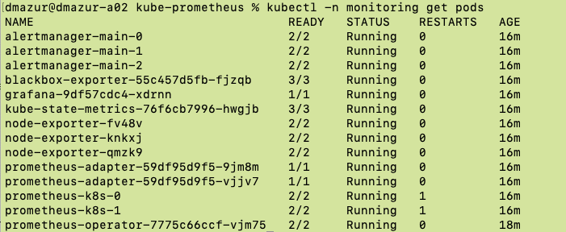



% kubectl -n monitoring port-forward pod/grafana-<suffix> 3000

open browser to <http://localhost:3000>



Login to Grafana with admin and password admin

>> you are then forced to create a new pwd (I used VMware1!)

Import a new dashboard

* Select the “+” sign and then the “Import” menu item:

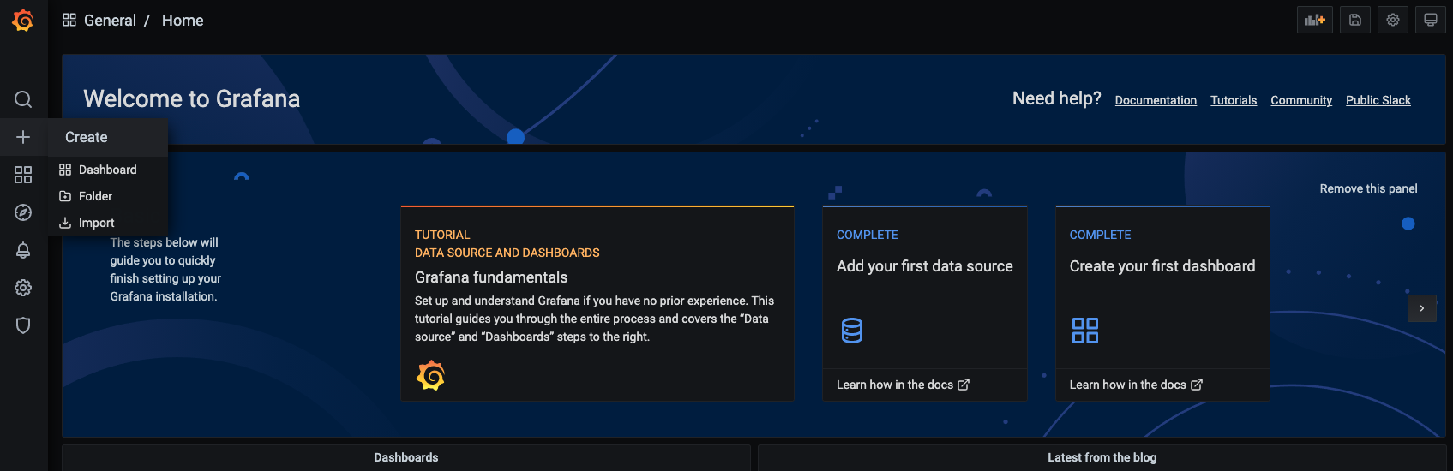



Enter “6336” under “Import via Grafana.com, then select “Load”. These are public dashboards you can use:

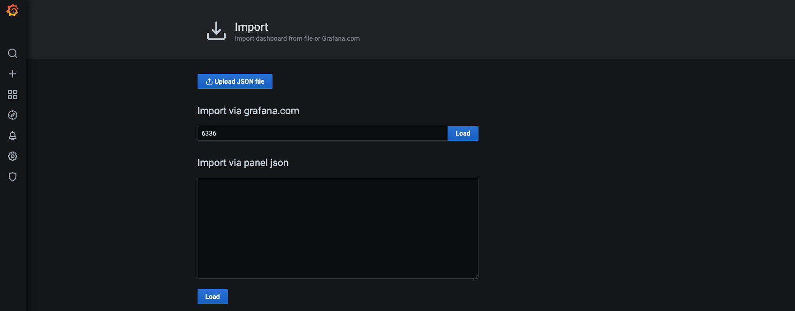



You then select the data source (we are using Prometheus):

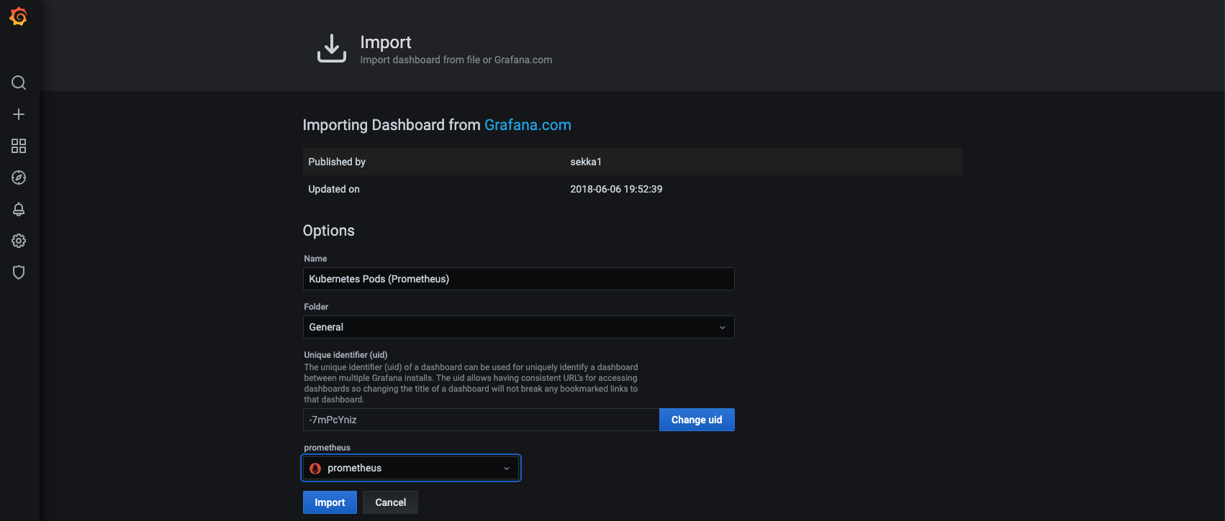



Type in the namespace “monitoring” at the top and hit return:

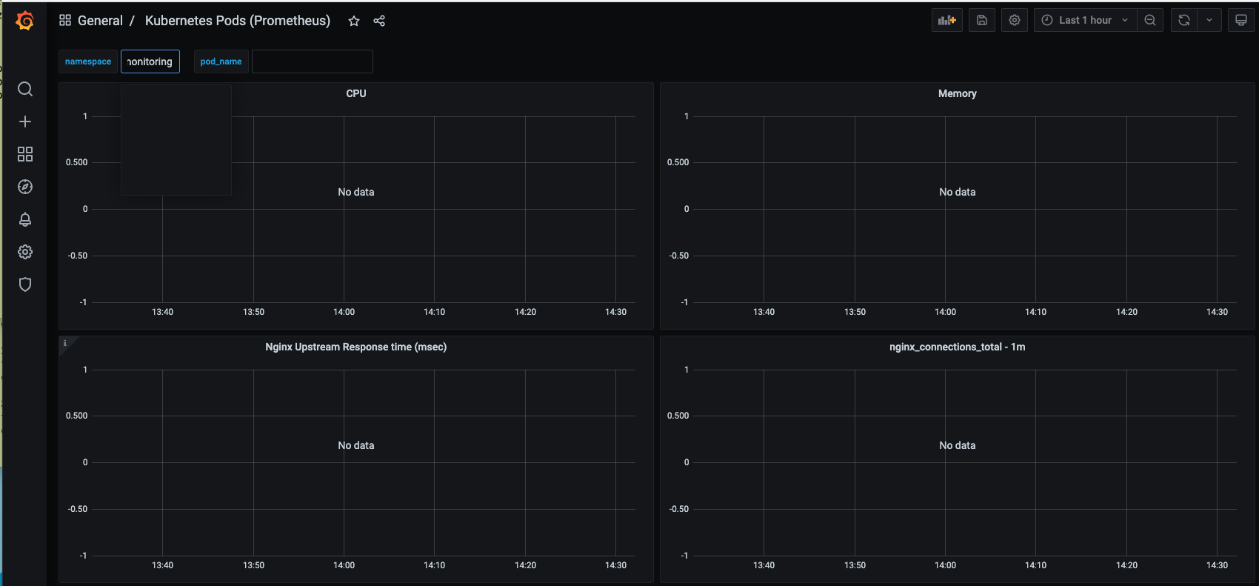



If you scroll down, you should see data similar to:

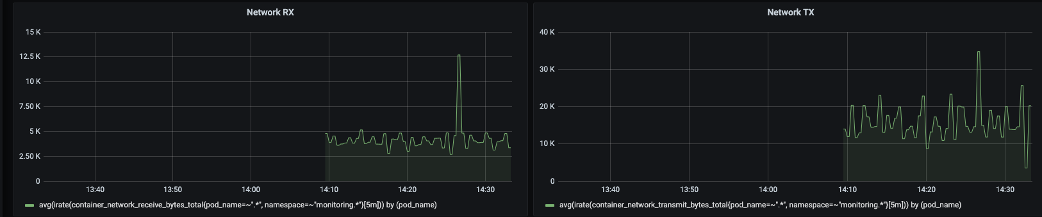

Also try to import dashboard 6417 for Kubernetes clusters:

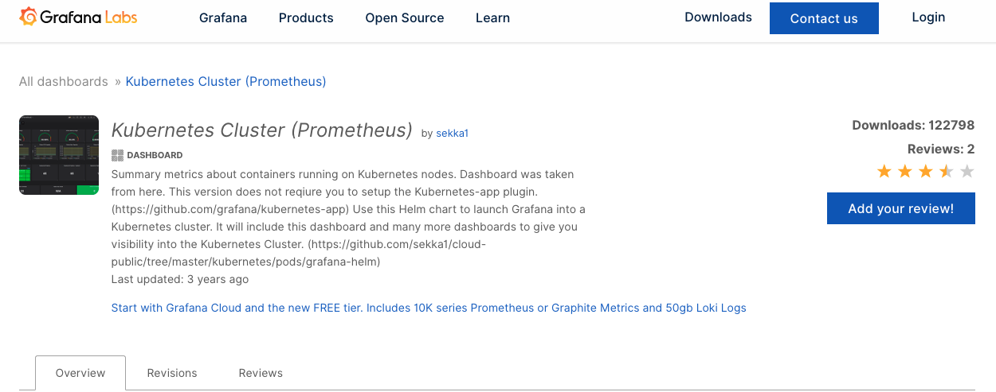

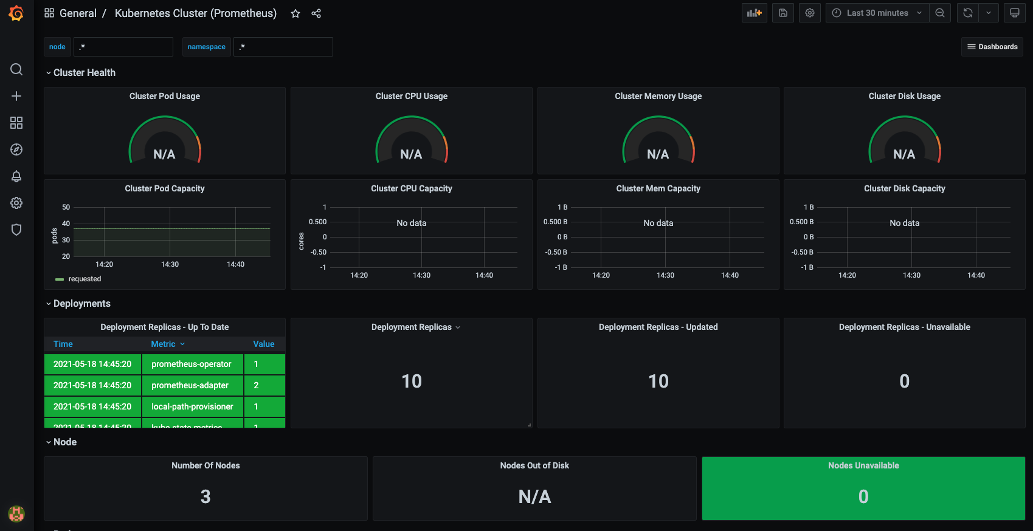



Note the “star” at the top for your dashboard

NB – fix for missing CPU & Metrics widget data can be found here: <https://github.com/vegasbrianc/prometheus/issues/109> (you need to edit the affected widget and update the formulae as metrics names have changed)

You can get other official and community dashboards here:

* https://grafana.com/grafana/dashboards

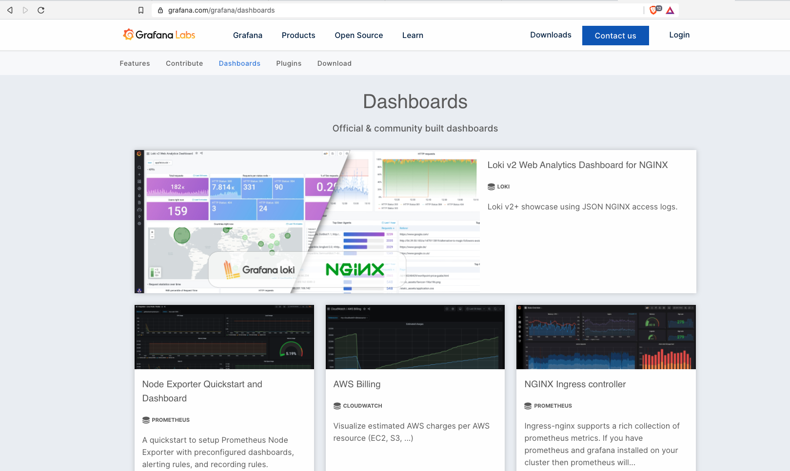

Back over in octant, take a look at “Applications” to see the workloads and resources running:

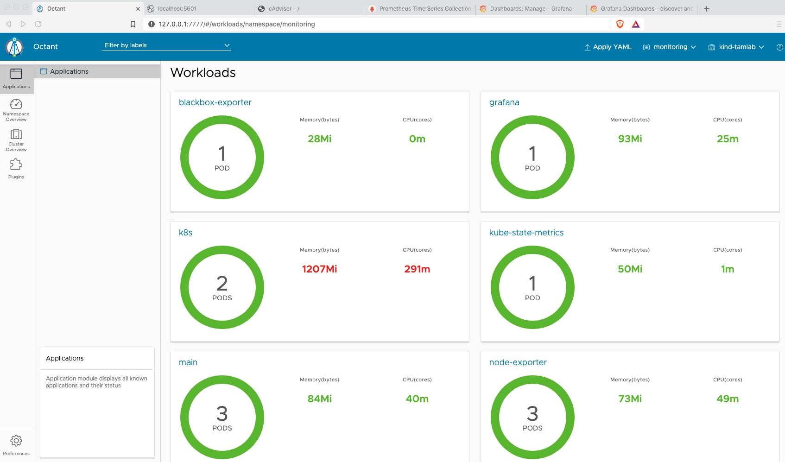

Now that we got it running using yaml files, let’s show you how easy it is to deploy using helm.

Follow the instructions on this website to use helm (skip the minikube commands since we are using KIND)

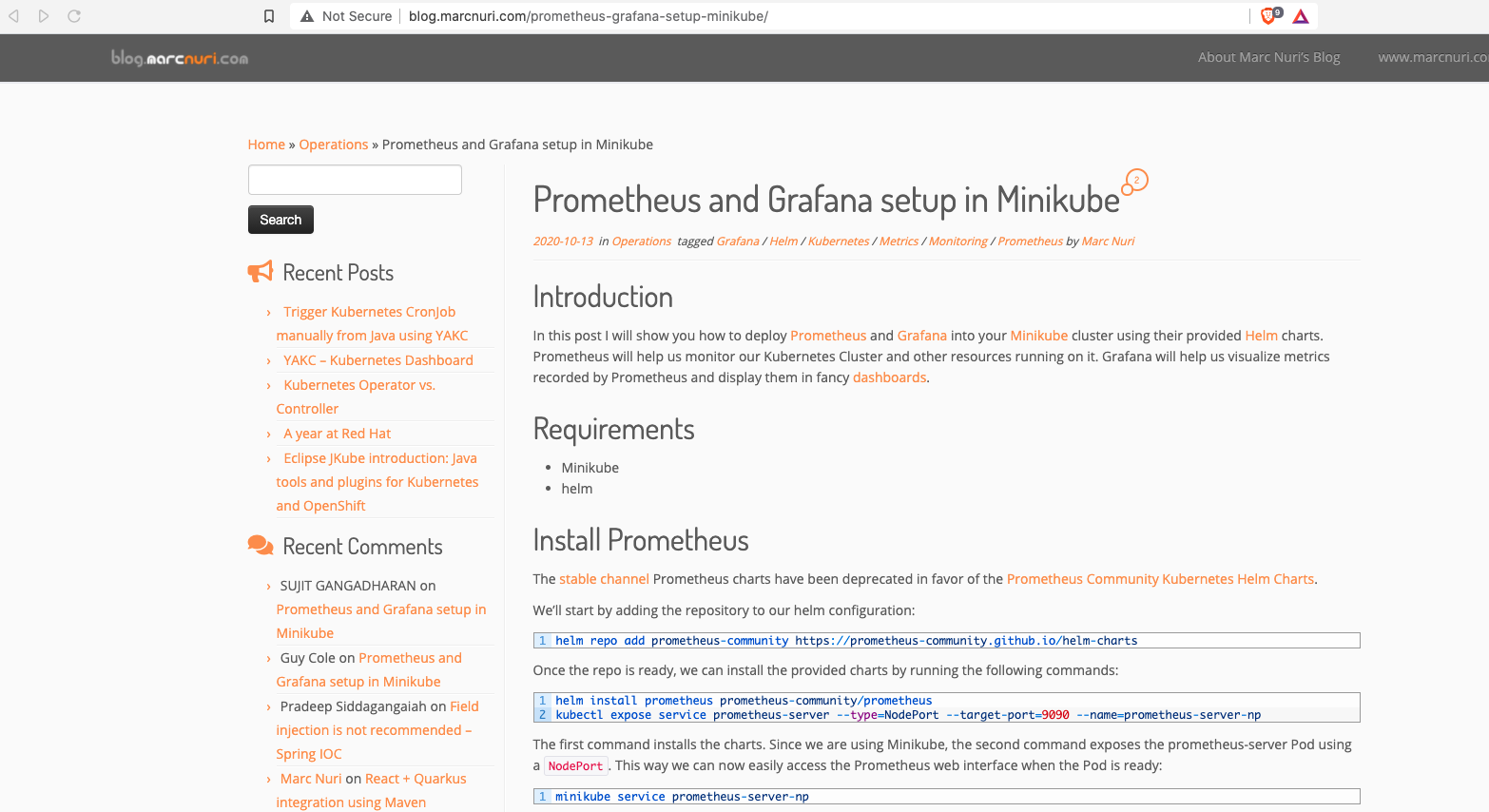

**Clean up old clusters**

Delete tamlab cluster if it exists

% kind delete cluster --name tamlab